|  |  |
| --- | --- |
| **Pre Requisites** | **CREATING NODE RED SERVICES, IBM WATSON, CLOUDANT** |
| Team ID | PNT2022TMID48141 |
| Project Name | Project – Personal Assistance for Seniors Who Are Self-Reliant |

# NODE-RED DESIGN WITH FORM NODE:

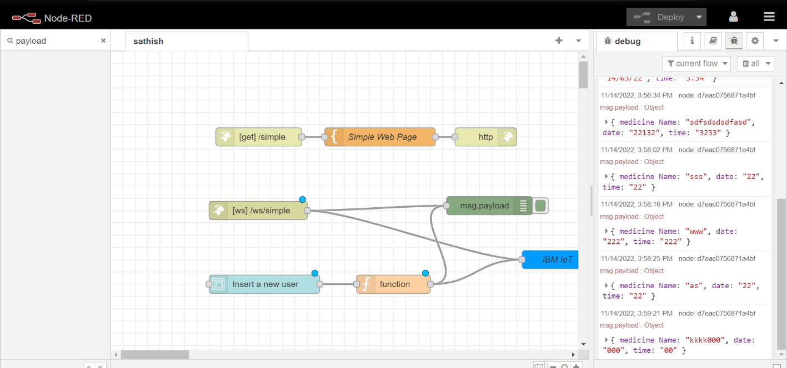

**FORM NODE:**

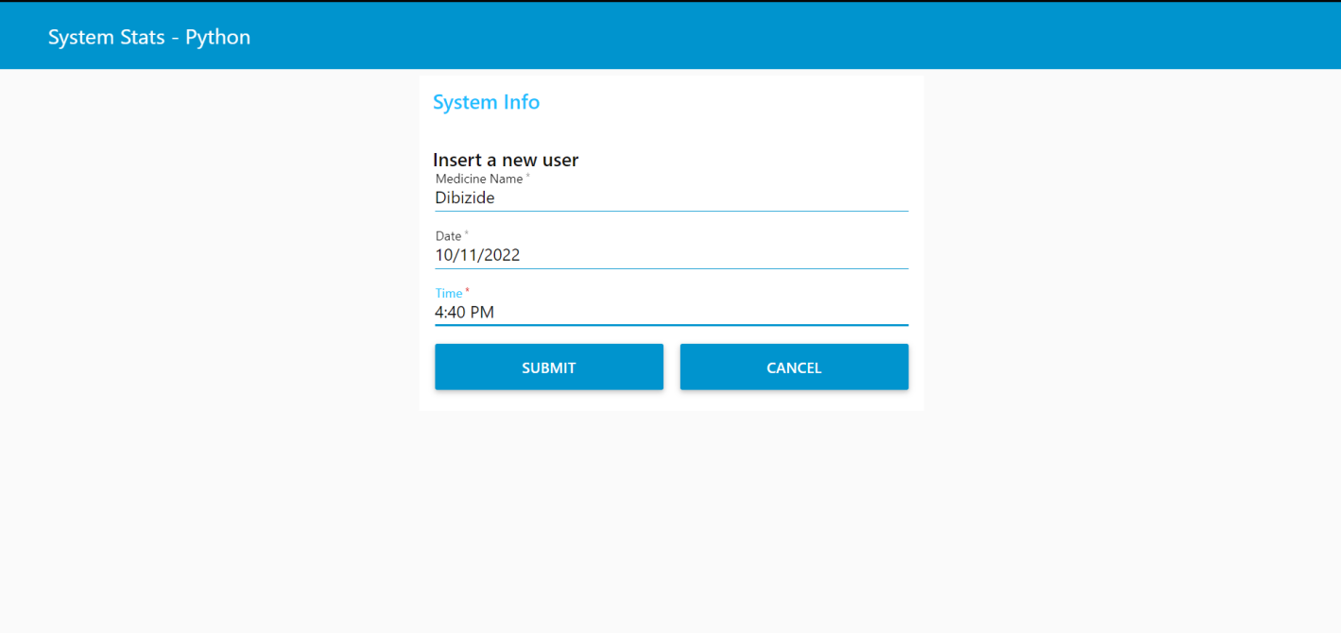

**CREATING IBM PLATFORM:**

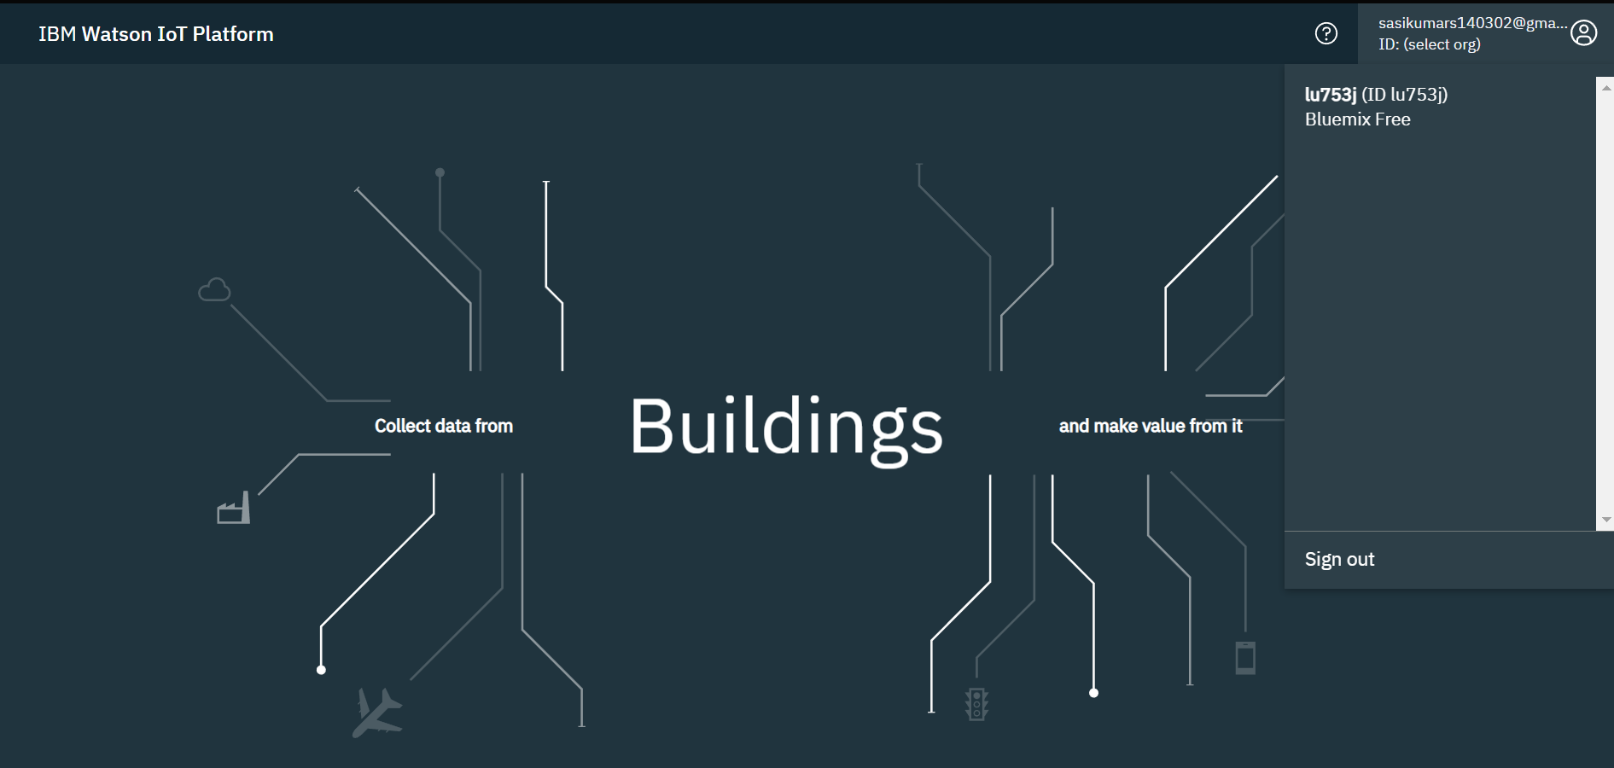**PRINTING THE VALUES IN IBM WATSON:**

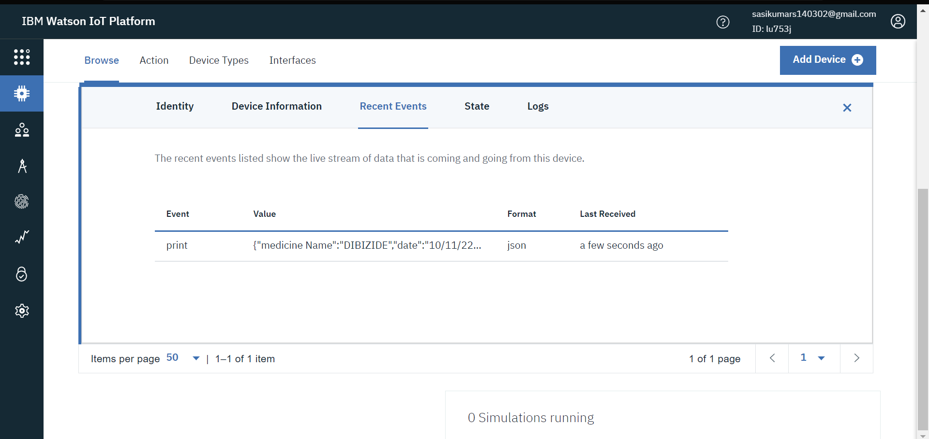

**CLOUDANT SERVICES:**

